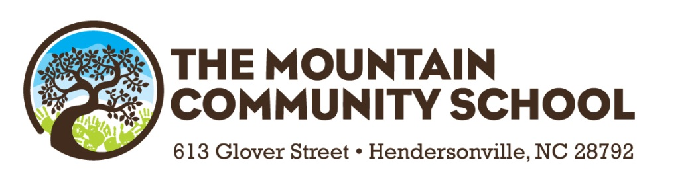

July 9, 2019

Dear TMCS Families:

I hope summer break has been relaxing and fun. As we get ready to launch the 2019-2020 school year, I want to welcome our new students and families to the TMCS community and offer some insight into what lies ahead.

Before I begin I would like to make an important dedication to a very sweet furry friend who was a special part of TMCS for close to a decade. Snickers the rabbit held a warm place in all of our hearts. He lived a beautiful life filled with lots of leafy greens, treats, and pets from loving children. He passed this summer which is very sad, but he will always live in my heart and the hearts of many.

Introducing The Dream Team
I am happy to report that we have the same fantastic players on the TMCS staff returning for the 2019-2020 school year, with just a few changes. Deanna Hill, the teacher assistant in kindergarten has retired after 15 years of amazing service. Deanna will be greatly missed by us all! The new kindergarten teacher assistant will be Hunter Strong. Hunter has spent the last two years as the assistant in 1st grade, and I have to say is somewhat of a “rock star”. She is excited to work alongside Michele Dickinson as she joins the kindergarten team.

Joining Ms. Kelly as the first grade teacher assistant will be Melissa Maxwell. Melissa joined the TMCS staff last year as a playground supervisor and intervention specialist, working with small groups of students in reading and math. She is a certified Pre-K teacher and will bring a lot of hands-on experience as she partners with Terri Kelly in the classroom.

What About the Curriculum?
Learning Through Expeditions continues to thrive. All classes will continue to offer expeditions throughout the course of the school year. For the new families joining our community, Learning Through Expeditions is learning by doing, with a particular focus on character growth, teamwork, reflection, and literacy. Expeditions are units of study that engage students, challenge their thinking, and teach them critical problem solving skills. Expeditions often take our students outside the walls of the classroom into the community as they examine issue that impact our society. We will host several Expedition Nights throughout the school year to showcase student work and give our students the opportunity to share their passion for what they have learned.

School-wide math instruction and interventions will be an area of focus for us during the 2019-2020 school year. The overall goal is to increase the level of fluency with our younger students, offer support in the way of math intervention programs to those in need, and challenge those students ahead of the curve. We have purchased a new math intervention program that some of our students will have access to, and we will also be implementing some Engage New York math strategies in K through 4th grade.

I am excited to announce that our staff will be participating in Trauma Resilient School Training this year. In the U.S., nearly two out of every three children experience a potentially traumatic event by age sixteen. Trauma impacts a child’s school performance, impairs learning, and causes physical and emotional distress. In addition, trauma impacts not only the individual child, but also other students, adults who interact and work with the child, and the respective schools and communities.

We have partnered with Center for Trauma Resilient Communities to provide staff development so we can better understand and serve all of our students in this regard. We will also be hosting an evening session for parents to help increase awareness on the effects of trauma and explain how to help build resilience as we move forward to support our children.

Programs That Make a Difference
Barbi Brittain and Doni Ward are excited to take the AIG (Academically and Intellectually Gifted) program to the next level this year. They have some amazing challenges in store for our bright young minds. We formally identify AIG students in 3rd grade, but they will also work with our younger students from time to time in their classroom environment providing some enrichment activities.

We will continue our partnership with the St. Gerard House by offering support and ABA therapy to identified students. Applied Behavior Analysis (ABA) is a type of therapy that focuses on improving specific behaviors, such as social skills, communication, reading, and academics as well as adaptive learning skills, such as fine motor development. This program has been highly effective for both our students and staff.

Let’s get started!
I’m so excited to get the 2019-2020 school year underway. Please know we are here to provide a positive learning experience for your child and we can best accomplish this goal when we work together. Take the time to get involved in your child’s school experience and this wonderful school community. All students and teachers will benefit from your support.

On behalf of the entire TMCS staff I want to extend a sincere thank you for your belief in our school and for entrusting your child in our care. We will continue to dedicate our time and energy to provide a quality educational experience to the students and families we serve. It’s going to be an AMAZING year, so let’s get started!

In Gratitude,

Denise Pesce
Principal

